Who is who?

Town Rector
Revd. Catherine Tucker (Interim)

Town priest
Revd Melissa Carter


Churchwardens
Ms Camilla Otaki (07578220209) and Mr Richard Harman (07871375986)


Church Secretary
Mrs Betty Paramor – 01304 203256

Church Sacristan
Mrs Jackie Cray



Church hall manager
Mrs Betty Paramor

Church Hall booking secretary
Mrs Betty Paramor (01304) 203256)

Dover Deanery Synod reps
Mr Michael Parkinson and Mr Chris Tyler

Christians together in Dover
Mrs Nanette Gleeson & Sue Jarrold

Christian Aid rep
Mrs Sue Jarrold

Safeguarding and child protection
Mrs Maggie Tyler & Mrs Sue Jarrold

Worship Band
Alastair Mackie, Lyn Faber, Maggie Tyler

Sunday morning hall worship
Alastair Mackie and team

Junior Choir
Mr Charles Spanner





October 2023
The Parish Magazine and
pew sheet of
St Peter & Paul
Charlton Church

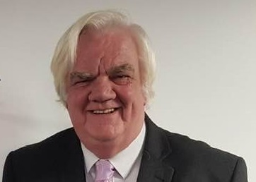
Dear Friends
Where will it all end? An interesting question about the future of our planet. Yes, the planet which we have been charged to look after by God. We are blessed that we are not subjected both physically or mentally to some things that are seen across the globe by adults and children. The sight of grieving communities are all too easy to find on television, social media or in newspapers. If it not man’s inhumanity to fellow man, severe weather, or earthquakes its climate change. I believe that, as Christians, we should set an example to others less fortunate. We watch our television sets or read the news of tragic events and we respond…or do we?

As individuals we have limited funds. Only so much to go around. There are many worthwhile causes that we financially support. For some that does already include giving to disaster funds, charities and groups that support the vulnerable, needy, homeless etc.

As Churches we have limited funds. There are many worthwhile causes that we financially support. British Gas, EDF and, of course, our Parish share. Only so much money to go around.

Utilities are very difficult to cut off. Those bills need to be paid. So that leaves the Parish Share. Do we need to pay it? This is the largest cost we, as a church, annually incur (outside of major repairs). As treasurers we are chased to see if it can be paid. The reality here, at Charlton for 2023, will be no. Retired clergy and courses for training have to be paid along with other sundry matters to Canterbury.

Wouldn’t it be great to think that Canterbury would be able to slash the 2024 Parish share to half of this years. Our mission to disaster funds and other worthwhile charities would greatly benefit. For sure.

Chris Tyler Editor
THOSE WHO NEED OUR PRAYERS FOR HEALING AND WHOLENESS
Lynne Bebbington, Kay Dawson, Sam Fields, Amy Mears, Thomas Mears, Kim Needy, Charlotte Richards, Derek Robinson, Jessica Taylor, Christine Williams, Bernie Williams, Albert Wall, Pat Weathered, Jack(5), Barbara Williams, Ian Buckley, Alison Askew, Min Gallagher . Paul Clayton Jayden (child) (Leukaemia), Danny Boyce. Revd. Melissa Carter, Barbara Spicer, Will Scamp and anyone else known to us.

THOSE WE REMEMBER IN CARE AND NURSING HOMES
Zenia Graves, Jane English, Wendy English, Sheila McLeish
Toby Marchand and Joyce Molyneux.

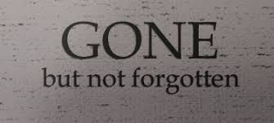
THOSE RECENTLY DEPARTED
David Matthews

Dear Father, help protect all in care at this time. May the Father keep them safe. The Son protect them, and the Holy Spirit always remain within their hearts.
THOSE WHO’S ANNIVERSARIES FALL THIS MONTH
Oct 1st: David Bromley; Gertrude Newton; Vi Figg. George Pitts:
Frank Benjamin: Jim Hawkins
Oct 2nd: Eliza Hollway; Kathleen Rusted; Reginald Hogbin; Arthur O’Brian
Oct 3rd: Winifred Reilly
Oct 4th: Mary Johnson; William Clark; George Holliday; Edna Stokell:
Colin Marsh
Oct 5th: Ilma Howard; Lilian Edwards
Oct 6th: John Howard
Oct 7th: Bert Newby; Rose Matthews
Oct 8th: James Snell (priest)
Oct 9th: Edwin Castle
Oct 10th: Caroline Richards; Rose Buddle; William Jopson; Patricia Corr
Oct 11th: Maddie Marchand
Oct 13th: Jay Brenchley
Oct 14th: Lawrence Adams; Frederick Sangster
Oct 15th: Joseph Butcher; Maude Finnis; Cecil Wyborn
Oct 16th: Frances Blomfield; Thomas Youden; Edward Pope;
Gladys Coleman; David Birch: Ann Yarrow
Oct 17th: Robert Porter; Alan Wanstall
Oct 18th: Phoebe Sanderson; Albert Smith; Helen Graves
Oct 19th: Albert Topliss, Val Crowley
Oct 20th: Alice Slater
Oct 21st: Ernest Kemp; Thomas Foad; Peggy Davidson: Mollie Greenstreet
Oct 22nd: Richard Pake; Arthur Linscott; Denis Clifford
Oct 24th: Stephen Terry; Harry Bland; Sybil Collier: Peggy Reader:
Bob Healing
Oct 25th: Helen Newby; Arthur Bouxman, Dorothy Russell
Oct 26th: William Embry; Emma Marsh, Myna Birde
Oct 27th: Olive Gilchrist; Claude Hatfield
Oct 28th: Olive Batty; Dilys Wynn; Priscilla Knott
Oct 29th: Ann Fletcher: Elsie Barnes: Robert Manuel
Oct 30th: William Nowers
Oct 31st: John Melhuish

May God always walk with them.
SERVICES / CELEBRANTS FOR OCTOBER
LITANY
9.30am - Rev Catherine or Lay lead
6th October 13th October
20th October 27th October
- Please check beforehand in case of holidays or cancellations

THURSDAY SAID EUCHARIST
9.30am - Rev. Melissa
5th October 12th October
19th October 26th October
- Please check beforehand in case of holidays or cancellations

SUNDAY EUCHARISTS
1st October Trinity 17 – Proper 21 - GREEN
08.00 SAID - Reverend Catherine Tucker
09.30 SUNG - Reverend Catherine Tucker

8th October Trinity 18 – Proper 22 - GREEN
08.00 SAID - Reverend Catherine Tucker 09.30 SUNG - Reverend Catherine Tucker

15th October Trinity 19 – Proper 23 - GREEN
08.00 SAID – Reverend Melissa Carter
09:30 SUNG – Reverend Melissa Carter

22nd October Trinity 20 – Proper 24 – GREEN
08.00 SAID - Reverend Melissa Carter
09.30 SUNG - Archdeacon Darren Miller

29th October Last Sunday of Trinity – Proper 25 - Green
08.00 SAID – Reverend Catherine Tucker
09.30 SUNG – Reverend Richard Woods

THESE ARE THE SERVICES AND COLOURS RELATING
THINGS MAY ALSO CHANGE WITH CLERGY
BIRTHDAYS OCTOBER/NOVEMBER
October
1st Joyce Kinden 5th Joyce Molyneux
7th Peter Gillham 9th Lyn Faber
16th Richard Harman 24th Karen Gillham

November
12th Josias de Souza 21st Sue Jarrold

PSALMS FOR OCTOBER
1st October Psalm 78.1–4, 12–16
8th October Psalm 65
15th October Psalm 106.1–6, 19–23
22nd October Psalm 99
29th October Psalm 119.9–16

GOSPELS FOR OCTOBER
Sun 1st October Matthew 21.23–32
Thu 5th October Luke 10.1–12
Sun 8th October Luke 12.16-30
Thu 12th October Luke 11.5–13
Sun 15th October Matthew 22.1–14
Thu 19th October Luke 11.47–end
Sun 22nd October Matthew 22.15–22
Thu 26th October Luke 12.49–53
Sun 29th October Matthew 24.30–35
READINGS FOR OCTOBER
Sunday, Oct 1st OT Exodus 17.1–7
NT Philippians 2.1–13
Thursday, Oct 5th Nehemiah 8.1–12
Sunday, Oct 8th OT Deuteronomy 8.7–18
NT 2 Corinthians 9.6–end
Thursday, Oct 12th Malachi 3.13—4.2a
Sunday, Oct 15th OT Exodus 32.1–14
NT Philippians 4.1–9
Thursday, Oct 19th Romans 3.21–30
Sunday, Oct 22nd OT Exodus 33.12–end
NT 1 Thessalonians 1.1–10
Thursday, Oct 26th Romans 6.19–end
Sunday, Oct 29th OT Nehemiah 8.1–4a [5–6] 8–12
NT Colossians 3.12–17

Some Readings may change. That is purely down to the discretion of the Priest.

30 SECOND MATHS CHALLENGE

1). 18 X 25 =?
2). 32 X 15 =?
3). 14 X 15 =?
4). 31 X 17 =?
5). 22 X 16 =?
6). 17 X 14 =?

Amazingly 15 out of 20 adults tested did noy get 6 out of 6
In 30 seconds. Have a go. Be a 5 out of 20 person.
Did you know?
October 31st – commemorates Martin Luther Day.
Martin Luther was born at Eisleben in Saxony in 1483, the son of a copper miner. After Erfurt University, fearful of death and judgement, he entered the Augustinian monastery in Erfurt but did not find the peace with God he anticipated. Taking his vows as a monk in 1506, he was ordained priest in 1507. He turned to the study of theology at which he excelled and by 1512 he had received both his doctorate and the chair of theology at Wittenberg University. At some point between 1512 and 1515 Luther had his so-called ‘Tower experience’ which marked a fundamental shift in his theology and faith. Through studying the Scriptures – notably Romans 1.17, ‘the righteous shall live by faith’ – he came to believe that Christians are saved not through their own efforts but by the gift of God’s grace, which they accept by faith. Once he had grasped this truth, he was transformed from someone fearful of God’s wrath into a fearless critic of a Church that was failing to teach this fundamental truth.
Luther’s increasing disillusion with the Catholic Church was brought to a head by the indulgence controversy which resulted in his Ninety-Five Theses, published on 31 October 1517. What was intended to initiate an academic debate quickly got out of hand and Luther was excommunicated in 1521. But his views struck a chord with others, and a bloc of anti-Catholic states began to emerge in Germany. By 1529 the word ‘Protestant’ had been coined to describe their beliefs. Though reform not schism was his aim, Luther stuck to his beliefs when Rome declined to reform itself, even along the conservative lines favoured by Luther. In addition to the doctrine of justification by faith he asserted the priesthood of all believers, the concept of national Churches, vernacular Scripture and liturgy, the use of hymns in worship and the freedom for clergy to marry.
Luther was successful in challenging the might of the Catholic Church partly because the intellectual changes of the Renaissance made such challenges acceptable, partly because the political situation in Germany was favourable to a new religious dimension, and partly because the technology to disseminate his ideas (the printing press) had recently been invented. But, most importantly, it was his personal courage and willingness to risk his life for the truth that allowed the Reformation to be born and to develop. He died at Eisleben in1546.
READERS AND INTERCESSORS FOR OCTOBER

Oct 1
OT Reader Richard Harman
NT Reader Maggie Tyler
Prayers Chris Tyler

Oct 8
OT Reader Chris Tyler
NT Reader Paul Hof-Bembridge
Prayers Betty Paramor

Oct 15
OT Reader Camilla Otaki
NT Reader Sue Jarrold
Prayers Alastair Mackie

Oct 22
OT Reader Betty Paramor
NT Reader Jackie Cray
Prayers Nanette Gleeson

Oct 29
OT Reader Nanette Gleeson
NT Reader Thelma Coleman
Prayers Chris Tyler

If you would like to join the existing team of readers for lessons or prayers, please see Richard or Camilla and you can be added to the existing list.
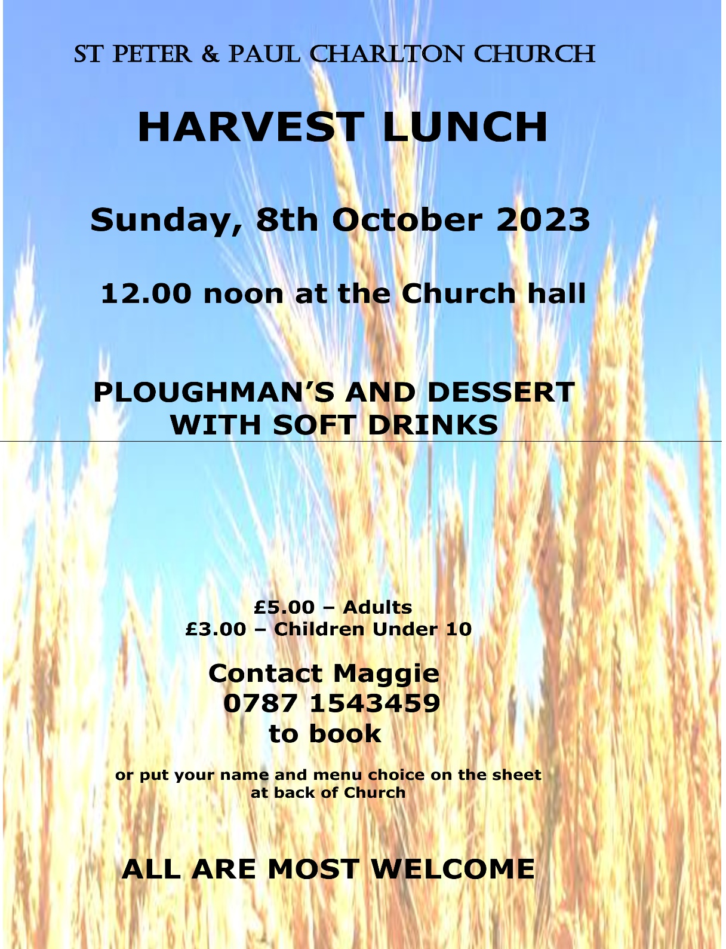
SOCIAL NEWS…….
WEEK DAY EVENT INCOME
DESERT ISLAND DISCS AMERICAN SUPPER
SPONSORSHIP £100
EVENT RAISED £186 TOTAL £286

GIRLS NAMES AMERICAN SUPPER
SPONSORSHIP £100
EVENT RAISED £180 TOTAL £280

NUMBERS IN SONG TITLES AMERICAN SUPPER
SPONSORSHIP £100
EVENT RAISED £155 TOTAL £255

PLACE NAMES IN SONG TITLES AMERICAN SUPPER
SPONSORSHIP £100
EVENT RAISED £135 TOTAL £235

FINE ART SERIES CHARLIE BROOKES
SPONSORSHIP £100
EVENT RAISED £45 TOTAL £145

MUSICALS 3 AMERICAN SUPPER
SPONSORSHIP £100
EVENT RAISED £TBC TOTAL TBC

THERE WILL BE A QUIZ BETWEEN NOW AND CHRISTMAS. WATCH THIS SPACE FOR A DATE. AN AUCTION IDEA IS BEING MUTED FOR 2024. A SERIES OF FINE ART CONCERTS STARTED IN SEPTEMBER. WATCH OUT FOR MORE DATES.

THE SOCIAL COMMITTEE ARE ALWAYS LOOKING FOR OTHER IDEAS TO RAISE FUNDS WITH THE EVER-INCREASING COSTS INVOLVED IN KEEPING OUR CHURCH OPEN. NO IDEA WILL BE DISMISSED BUT IT MAY NEED HELP IN PLANNING ON TOP OF THE EXISTING IDEAS WE HAVE.
QUIZ
1. Which Saint's feast is on Boxing Day? ST STEPHEN
2. What are the two former names of the Russian city, St. Petersburg?
PETROGRAD AND LENINGRAD
3. What saintly name is given to an atmospheric glow that appears on the extremities of pointed objects such as ship masts and church spires?
ST ELMO’S FIRE
4. Who is the patron saint of lost causes? C.SPANNER OR ST JUDE THADDEUS
5. Which European republic was founded by St. Marinus and his Christian followers? SAN MARINO
6. What event inspired George Bernard Shaw to write the play 'St. Joan'.
THE CANONIZATION OF ST JOAN OR ARC IN 1920
7. Where is St Edmund buried? THE ABBEY OF BURY ST EDMUNDS
8. According to folklore, what will happen if it rains on St. Swithin's day?
IT WILL RAIN FOR 40 DAYS
9. Which saint was the first Archbishop of Canterbury and founded the Christian Church in the South of England? AUGUSTINE
10. Who is the patron saint of doctors? ST LUKE THE APOSTLE

BAPTISMS 2023
OCTOBER
8TH 12.00 BODHI ROBERT WILSON
15TH 12.00 ISLA OLIVIA VICTORIA WILKINS
22ND 14.00 OLIVIA JADE WILLIS JONES
29TH 12.00 HENRY MARCUS COLE

NOVEMBER
11TH (Saturday) 12.00 MADISON MINNOCK (10 year old)

WEDDINGS 2023
NOVEMBER
4TH 14.00 DEBBIE AND IAN

HYMNS OCTOBER 2023
1st October Processional: 296 – Lord Enthroned in Heavenly spendour
Offertory: 357 – Father hear the prayer we offer
Communion: 445 – Rock of ages cleft for me
Recessional: 457 – The king of love my shepherd is

8th October Processional: 259 – Come ye thankful people, come.
Offertory: 264 – All things bright and beautiful
Communion: 276 - Bread of heaven on thee we feed
Recessional: 262 - We plough the feeds and scatter

15th October Processional: 5 – Hark a herald voice is calling.
Offertory: 459 – The Lords’ my shepherd
Communion: 282 – Faithful Shepherd feed me
Recessional: 294 – Just as I am

22nd October Processional: 52 – O worship the Lord
Offertory: 486 – We have a gospel to proclaim
Communion: 431 – O thou who camest from able
Recessional: 377 – Immortal, invisible

29th October Processional: 360 – Firmly I believe and truly.
Offertory: 372 – He who would valiant be
Communion: 485 – thy hand, O God, has guided
Recessional: 413 – Now thank we all our God

Poem about gardens
The kiss of the sun for pardon,
The song of the birds for mirth,
One is nearer God’s heart in a garden,
Than anywhere else on Earth.

A WRITTEN PIECE FROM WORLD WAR II
The bell tolls but not today for you laddie,
Bullets hiss and whistle all around
It tolls for other poor souls but not today for you laddie.

You look back and see old friends fall in crumpled heaps as the rain pours down from the angry heavens forming puddles of rain mixed with the blood of conflict.

It’s insane its madness this senseless premature taking of the innocent lives of many who did not want to be here but were ordered by men at home Sitting in front of their warm fireplaces.

One day the bell may well toll for you laddie. Pray you never hear it and you live to return to family and friends.

ANON.

The life that I have Is all that I have
And the life that I have Is yours.
The love that I have of the life that I have
Is yours and yours and yours.
A sleep I shall have. A rest I shall have
Yet death will be but a pause.
For the peace of my years In the long green grass
Will be yours and yours and yours.

a short poem written by Leo Marks and used as a poem code in the Second World War.
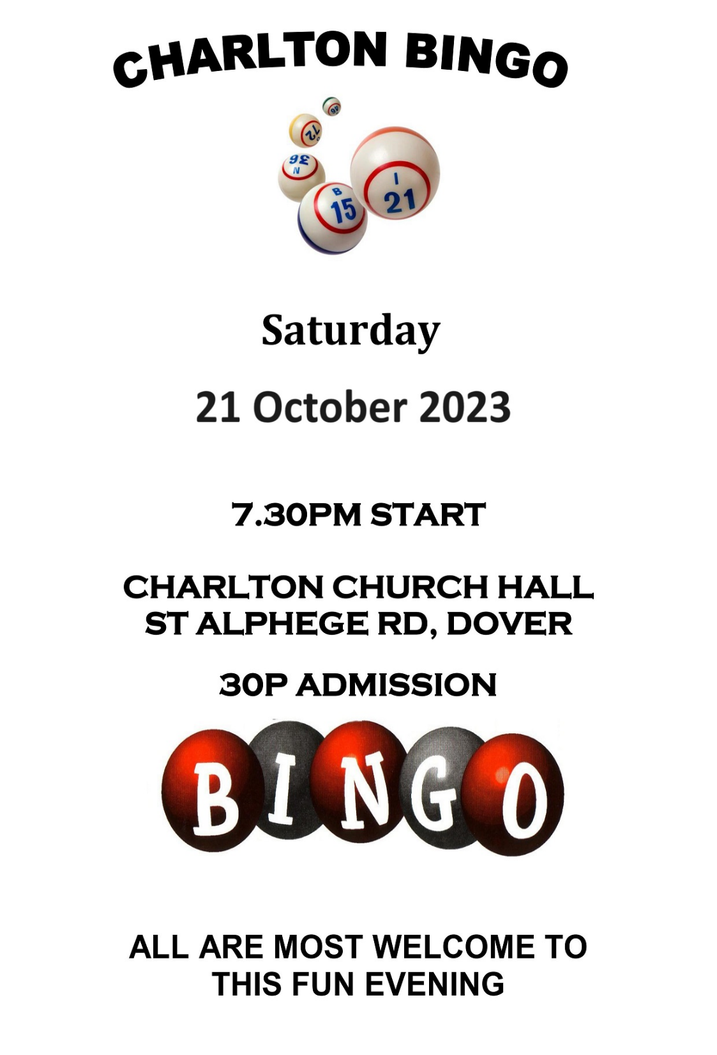

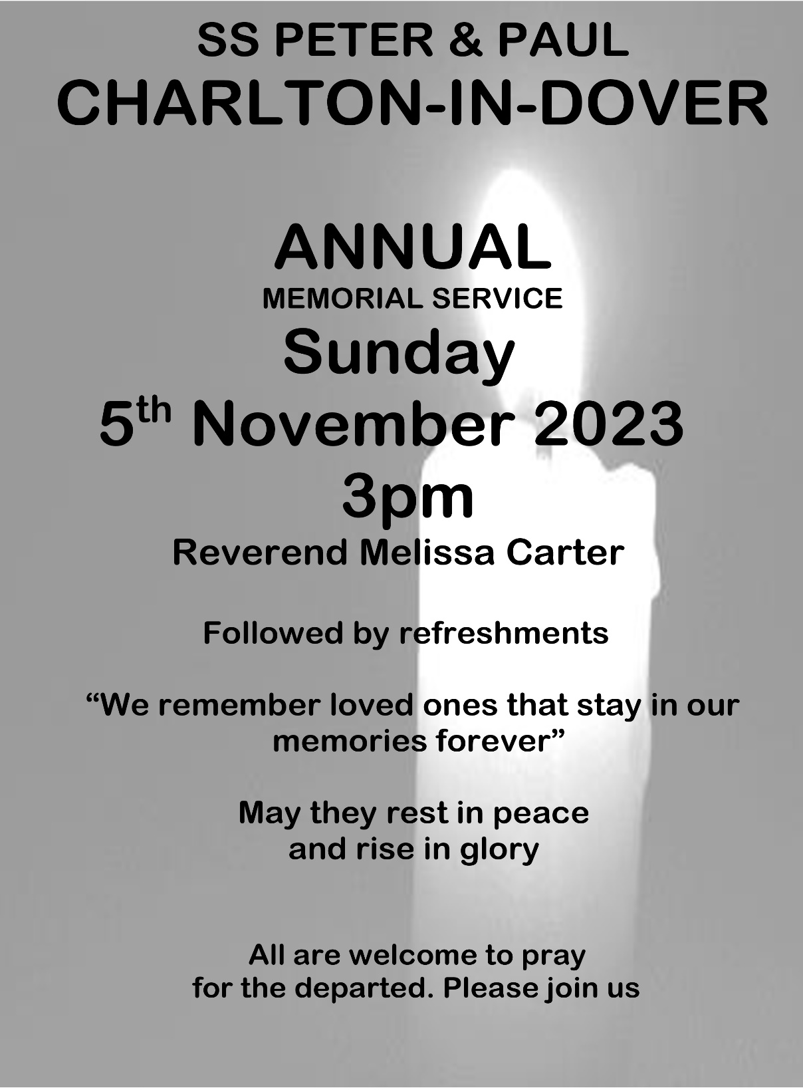
And finally a charming limerick by the theologian and crime writer Ronald Knox, inspired by Bishop Berkeley’s esse est percepi concerns about being and perceiving:

There was a young man who said, “God
Must find it exceedingly odd
To think that the tree
Should continue to be
When there’s no one about in the quad”

Which prompted this anonymous reply:
“Dear Sir: Your astonishment odd:
I am always about in the quad.
And that’s why the tree.
Will continue to be
Since observed by, Yours faithfully, God.”

Not a bad one on which to end ….

If you or someone you know would like a visit from or a chat with our Pastoral Care Team please contact

Revd Catherine Tucker 07709 618063
Revd Melissa Carter 07825 910116
Reader Chris Scoble 07988 853730
Reader Wendy Bowditch 07821 896877
Reader Graham Snellin 07502 292959
ALM Gill Neary on 07721 336956

ADVANCE NOTICE – IT’S COMING FAST !!

QUIZ. ALL ANSWERS BEGIN WITH THE LETTER “P”
1). Who’s chemical number is 19?
2). Lima is the capital of what country?
3). Russia’s leader surname?
4). Capital of Cambodia?
5). Disney’s Peter?
6). Who’s chemical number is 15?
7). This Capaldi was a Doctor Who.
8). How many dinosaurs are listed beginning with “P”
20 26 28
9). He was a dirty dancer. Who is he?
10). This Benjamin was an 1980 American comedy film
11). Which former German empire was abolished in 1947?
12). What is the name of the Children in Need teddy bear?
13). What is the name of the Lion in the children’s
programme “The herbs”?
14). The famous female singer was a clark. Who is she?
15). Claudius. 2nd century Greek mathematician?
16). This man loved dogs. Who is he?
17). The Devonport Dockyard is where?
18). This Argyle is not Scottish.
19). He sang about 19 in 1985.
20). Martin Luther bought about this movement.
21). Which council was founded on 1st May 1708?
22). Who painted “Guernica” in 1937?
23). Who sang about a lemon tree in 1962?
24). This female Faith can sing!
25). Sicily's cultural, economic and tourism capital is?

Answers next month…
